# Homework #3: Policy Based Management

|  |
| --- |
| * This is an individual assignment, and is worth 20 points. * The due date is midnight on Monday, February 8th. * Use the following naming convention: homework, underscore, last name, first initial, and extension (e.g., Homework #3_ImG.docx). If you do not follow the convention, I will deduct 1.0. |

* Screenshots should show the full contents of the conditions and policy you have created, not just the names.
* **Task 1.** Show in a screenshot the condition(s) you have created.

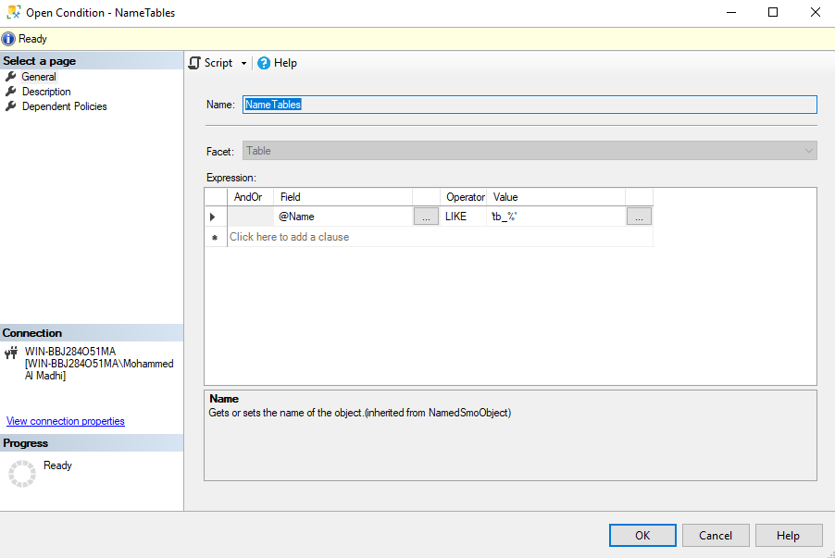

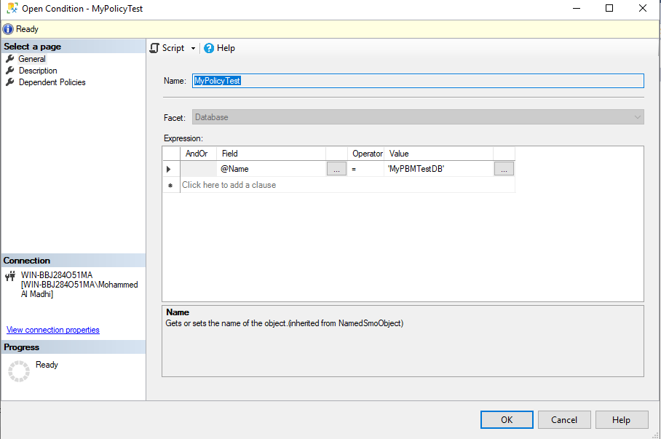

* **Task 2.** Show in a screenshot the policy you have created.

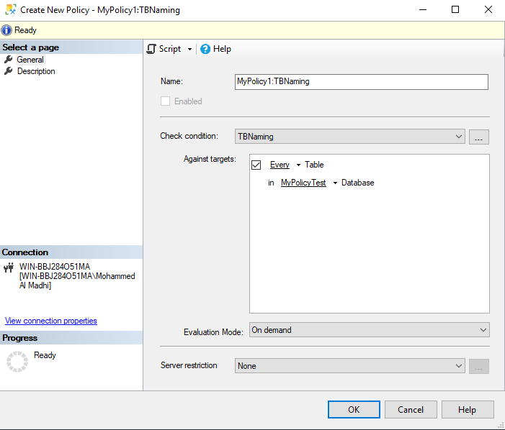

* **Task 3.** Show in a screenshot the test results using the four tables that are provided above.

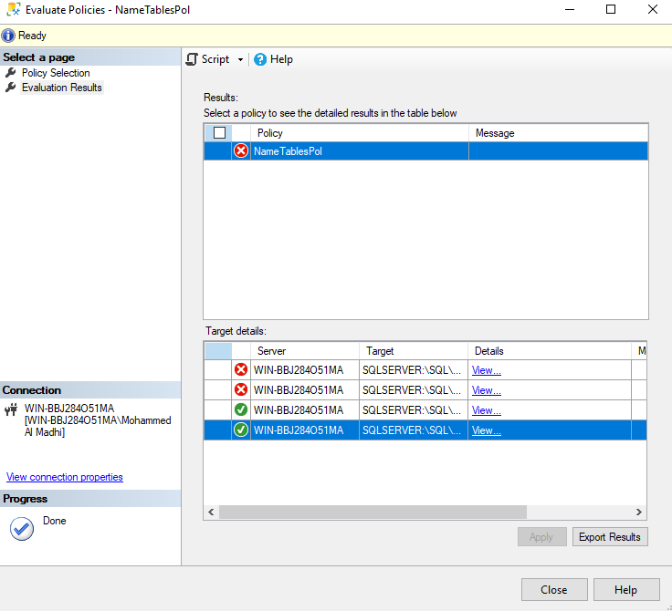

* **Task 4.** Explain the results at Task 3.

When using the first two scripts, for example this “CREATE TABLE [dbo].[Department1](

[DepartmentID] [int] NOT NULL,

[DepartmentName] [nvarchar](50) NOT NULL,

[DepartmentDescrp] [nvarchar](50) NOT NULL,

)” The **table name** does not include “tb_” naming convention thus our policy states that it must be prefixed with it.

However, the second and last script does include “[tb_Department3]” for our **table names**